* Docker Installation and container Creation

1. Go to your VM and  insert following command

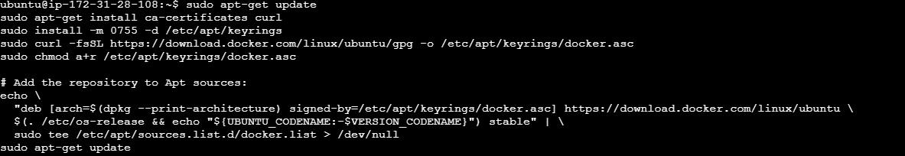

Above command will Set up Docker's apt repository

1. Install the Docker packages.

sudo apt-get install docker-ce docker-ce-cli containerd.io docker-buildx-plugin docker-compose-plugin

1. Verify that the installation is successful by running the hello-world image:

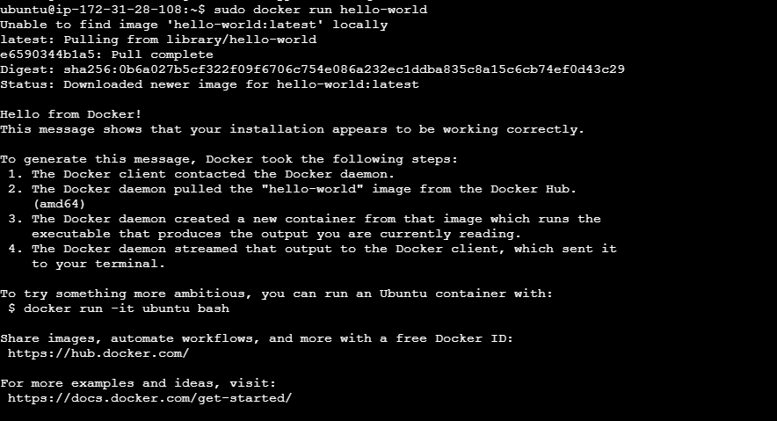

                 4.then create Container  using Following Command

          docker run -d -P nginx:latest

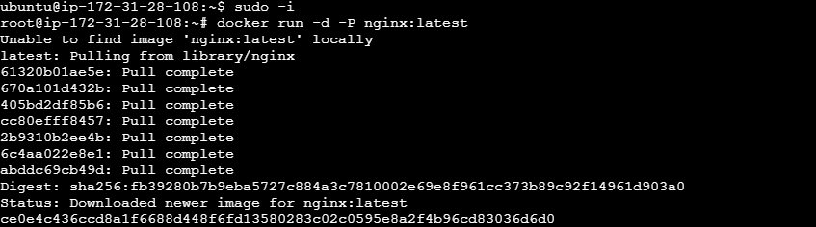

Above command will install ngenix Service on Container

                5. To check weather service is crated or not you need to  enter following                  command

           docker ps

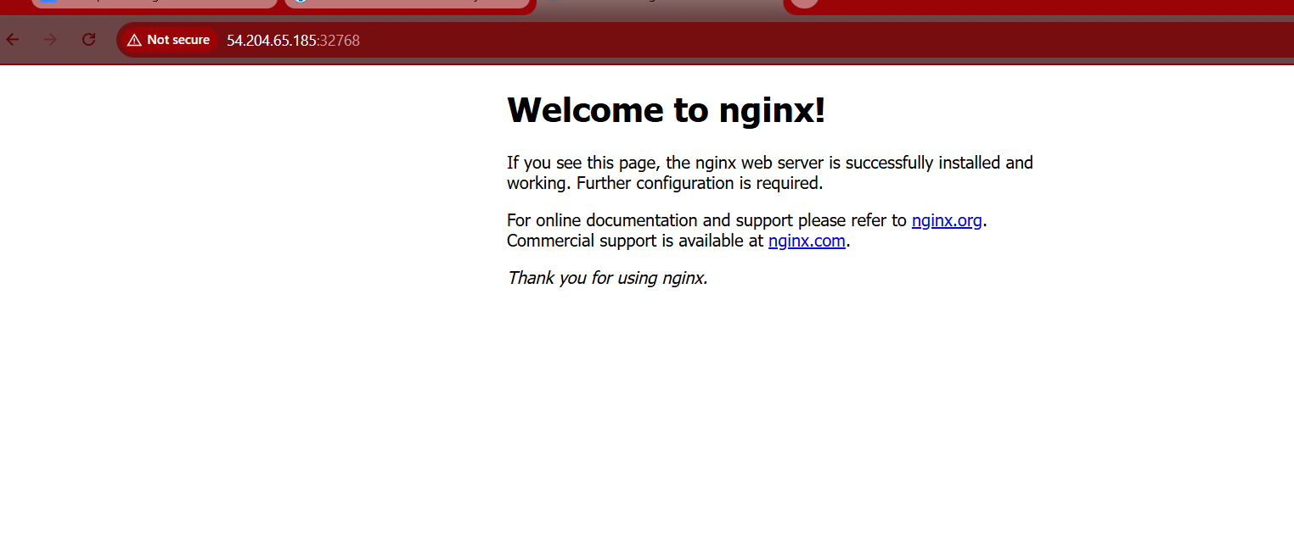

The ipofserver:32768 where 32768 is port for docker service